**SonarQube Setup**

<https://dzone.com/articles/how-quickly-get-started-sonar>

Following are two key aspects of getting Sonar and dependencies installed, configured and setup for usage.

* Installation of SonarQube
* Installation of Code Analyzer

**Installation of SonarQube**

* Download the SonarQube 7.3 Community Version from this link : <https://www.sonarqube.org/downloads/>
* Unzip the file under C: drive
* Go to unzipped folder find bin directory, then you will find list of folders based on OS platforms, as we have 64bit windows system hence go to **bin\windows-x86-64**
* Execute **StartSonar.bat** file, which will start SonarQube server in local, after getting message: “**SonarQube is up**” on Command-Line window, hit the URL : <http://localhost:9000/>, you will find below screen on browser :

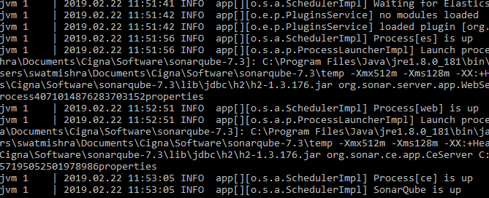

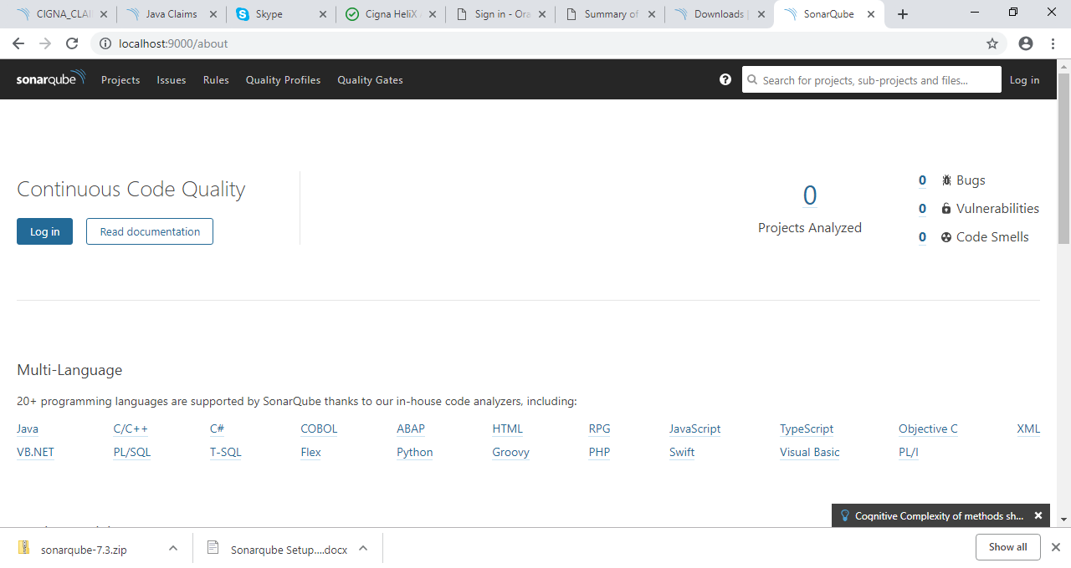

* You can be login as admin by providing Id and Password :
  + Id = admin
  + Password = admin

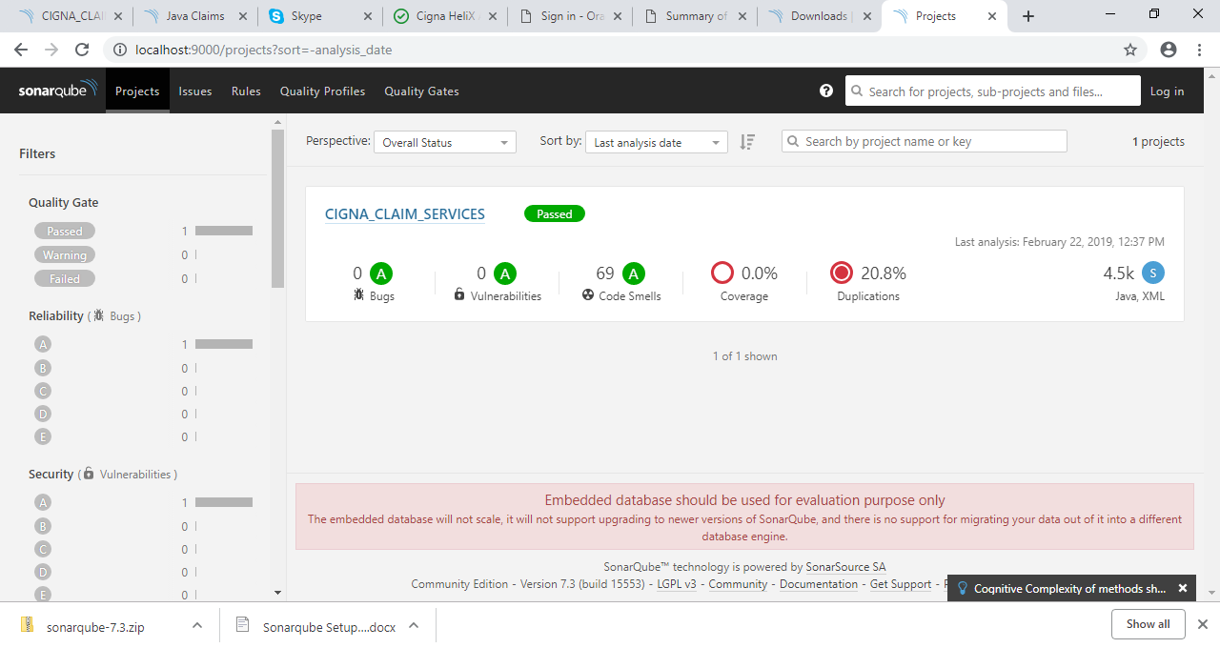

* Sonar comes with an embedded H2 database, by default. For quick setup and testing purpose, you may live with embedded database. However, for production and real usage, one may want to use production-read databases such as MySQL, Oracle etc. For configuration instructions, edit <install_directory>/conf/sonar.properties to configure the database settings. Templates are available for every supported database. Just uncomment and configure the template you need and comment out the lines dedicated to H2 database.

**Installation of Code Analyzer**

* Download Sonar runner from this URL : <http://repo1.maven.org/maven2/org/codehaus/sonar/runner/sonar-runner-dist/2.4/sonar-runner-dist-2.4.zip>
* Unzip this file under C: drive
* Now set below environment variables :
  + SONAR_RUNNER_HOME : C:\sonar-runner-2.4
  + SONAR_RUNNER_OPTS : -Xmx1024m (To increase Java Heap Size)
  + Path : Add New path as “%SONAR_RUNNER_HOME%\bin”
* To check path is set properly, just open fresh Command Line window and hit command **sonar-runner –h**, If above get executed, you are all set to analyze your first project with Sonar Runner.
* Create a configuration file in the root directory of the project, namely, sonar-project.properties, please find sample properties for STEPS project as below :

# must be unique in a given SonarQube instance

sonar.java.source=1.8

sonar.projectKey=CIGNA_CLAIM_SERVICES:project

# this is the name and version displayed in the SonarQube UI. Was mandatory prior to SonarQube 6.1.

sonar.projectName=CIGNA_CLAIM_SERVICES

sonar.projectVersion=1.0

# Path is relative to the sonar-project.properties file. Replace "\" by "/" on Windows.

# This property is optional if sonar.modules is set.

#C:\Users\swatmishra\Documents\Cigna\Project\SVN-Project\trunk\Helix\new-ui\claimsCust\java\claims-services-ejb\src

sonar.sources=C:/Users/swatmishra/Documents/Cigna/Project/SVN-Project/trunk/Helix/new-ui/claimsCust/java/claims-services-ejb/src

# Encoding of the source code. Default is default system encoding

#sonar.sourceEncoding=UTF-8

sonar.java.binaries=C:/Users/swatmishra/Documents/Cigna/Project/SVN-Project/trunk/Helix/new-ui/claimsCust/java/claims-services-ejb/target/classes

* Open a command prompt, and go to project root folder
* Execute “sonar-runner” command to run the analysis. You would see the analysis run
* Goto the browser and access the page, <http://localhost:9000>, you will find below screen :
* As in above screen, EIMESM-ES is processing, this will create a dashboard on screen as below :



